“ **E-Project Report ”**

SUBMITTED BY

1. Muhammad Umer ABID (1322584)

2.MUHAMMAD fARDEEN (1323357)

3. JAN SHER TARAZAI (1322647)

4. WAJID AHMED(1322580)

SUPERVISED BY

SIR TAQI RIZVI



E project report under the supervision of **SIR TAQI RIZVI** , APTECH, Federal B area, Karachi.

**[STATIONARY WEBSITE]**

**Batch – PR-2021- 06-E**

ACknowledgment

We Are Grateful To Our Faculty Sir Taqi Rizvi. Who Helped Us At Every Stage In This Project,Supported Us Through The Whole Journey Of Making This Website Quick And Productive.

group members



**Muhammad Umer Abid**  **Student I.d no** : 1322584  
(Coding , styling ,designing )   
**Immediate Contact**: ([muhamadumer629@gmail.com](mailto:muhamadumer629@gmail.com) , 03422380923 )



**Muhammad Fardeen**  **Student I.d :**  1323357(content finding, page creations of fine arts,)   
Immediate Contact: ([muhammadfardeen880@gmail.com](mailto:muhammadfardeen880@gmail.com) , 03032960233)



**Jan Sher Tarazai Student I.d :**  1322647(assistance in coding, content finding )   
Immediate Contact: ([janshertarazai003@gmail.com](mailto:janshertarazai003@gmail.com) , 03479078563)



**Wajid Ahmed**  **Student I.d :**  1322580(documentation, page creator)   
Immediate Contact: ([wajidahmed907@gmail.com](mailto:wajidahmed907@gmail.com) , 03103506305)

# **Indivisual evaluation**

|  |  |  |  |  |
| --- | --- | --- | --- | --- |
| **Names** | **Research** | **Coding** | **documentation** | **Content** |
| Muhammad Umer Abid | 80% | 80% | ---- | 20% |
| Jan sher tarazai | 20% | 20% | ---- | 40% |
| Wajid ahmed | ---- | ---- | 100% | ---- |
| Muhammad fardeen | ---- | ---- | ---- | 40% |

# **PREFACE**

**Introduction of Report:**

We have made a website for “**Stationary**”. Which includes all the products of stationary such as pens, rubbers, arts, eraser, calculators and other products too. Every page has separate products detail along with their price and description.

**Short Description of the Project :**

This website includes the combination of **Html**, **Css**, and **Bootstrap**. **Css** codding is used to change the displays to flex and grid system, make website responsive, adding margins and paddings, changing the colors, for using varying fonts of Language etc. Bootstrap is used for making cards, making navigation bar responsive and many more.

**Brief Description of Website:**

We have made an E-commerce website titled as “Stationary Website”. Which includes different categories of products relating to stationary items such as : different types of pencils, pens , markers , color pencils, sharpeners, scales, gums, calculators and ink. The Website also includes the Gallery Page which includes art work, made using by the use of our products, reference to different artists related to this field. We also have a blog page, which contains blogs taken from different bloggers around the globe.We have pages regarding the description of our company, the privacy policy, and terms and conditions. There is a separate page of About us which includes a brief description of company’s production. The footer of the website includes number of pages for the help of visiting clients like FAQ’s (Frequently asked questions), and contact us page (for user’s assistance to contact us ).

**Conclusion:**

By making a visit to our website, user can easily purchase anything related to the stationary items from a vast range of products in affordable prices. Moreover discount is also offered for schools, offices and all other educational Institutes.

“ vISUAL rEPRESENTATION OF OUR website ”

Home Page

The Home Page consists of a tag line describing the discount offer for offices and educational institutes. Moreover, there is a logo place at the Top. The Colors used in websites are many as to attract user of any age group. The Navigation consists of different categories. Each Linking to a separate page, description of products and separate purchase process. On the Front Page there is a vast range of different products such as pencils, fountain pens, calculator, erasers and many more on which our website is totally based on. Below is the snapshot of it.

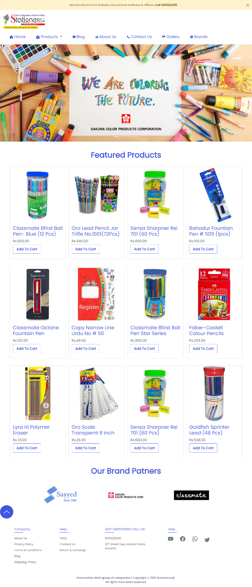

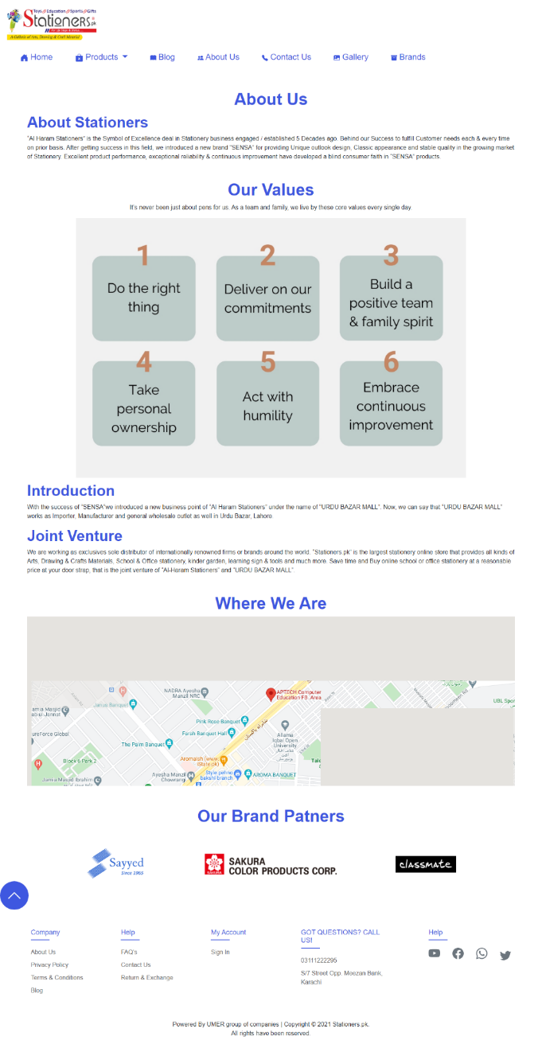About US :

The About us Page consists of primary purpose of ours site.  About Us page is to provide information about our website. So, it includes the basics, such as our contact numbers, establishment details and its long-term goals and mission and email addresses. Along with the address it also consists of a map directing towards our head office.

Description :

To make user totally satisfied during his purchase, we have put a description page which appears on clicking the product. Which Allows user to have complete information of the product along with Price, availability and a choice box which demands input in case of extra amendments.

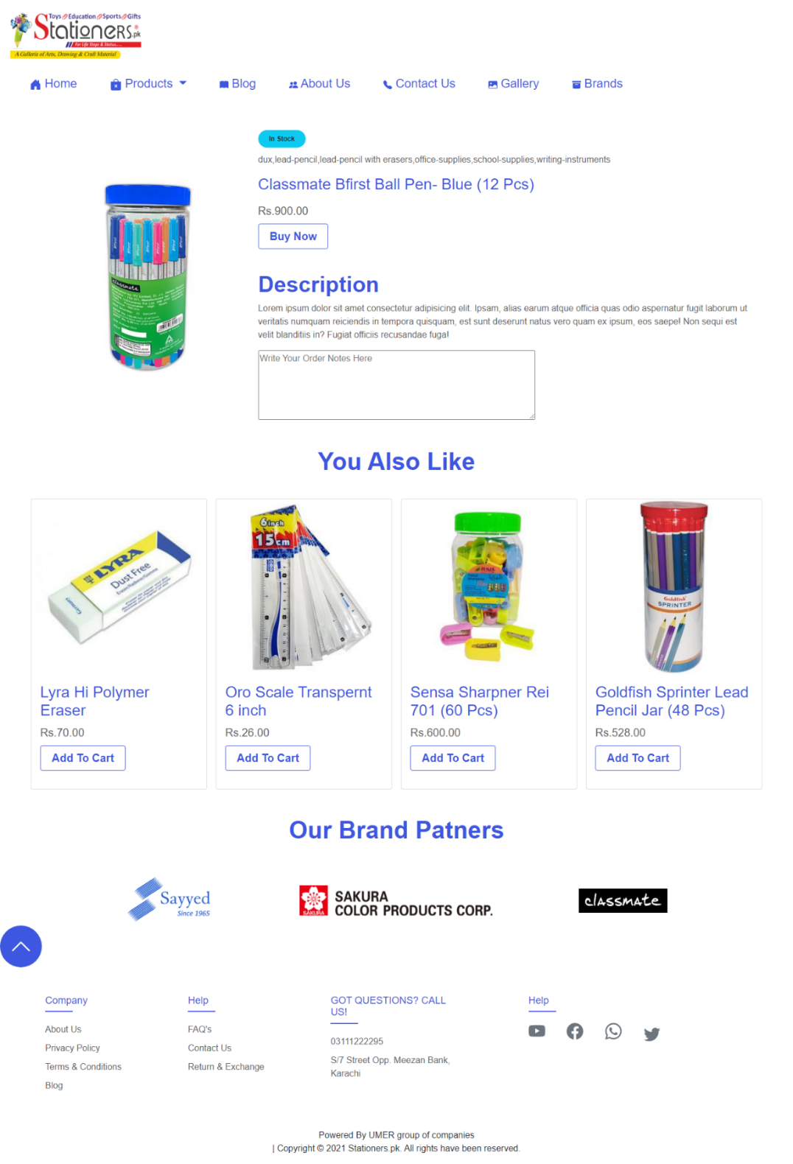

Gallery :

The Gallery Part Consists of History and different forms of arts from different artists all over the globe. There Are several pictures with are attached in it and have description about its origin and the artist.

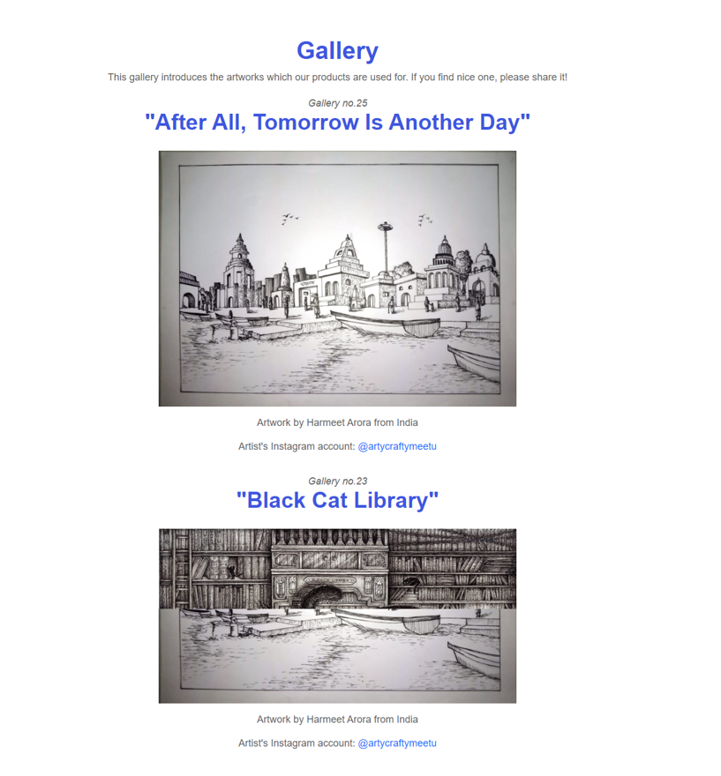

Login Form :

The Login Form Consists of general information input sections. Where The user with provide details like name, country, phone number just to register himself once for all and to make his visits better for the next time. It also consists of Information regarding our brand partners. Screen Shot is attached down below:

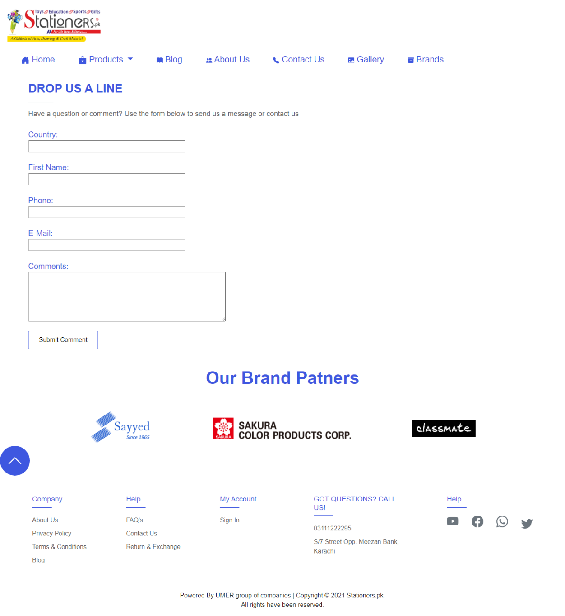

Buy Now :

After The User gets to the purchasing criteria, a buy now form appears in his front making him able to buy the product. This form demands contact information, complete shipping address and two separate options for cancelation and confirmation.

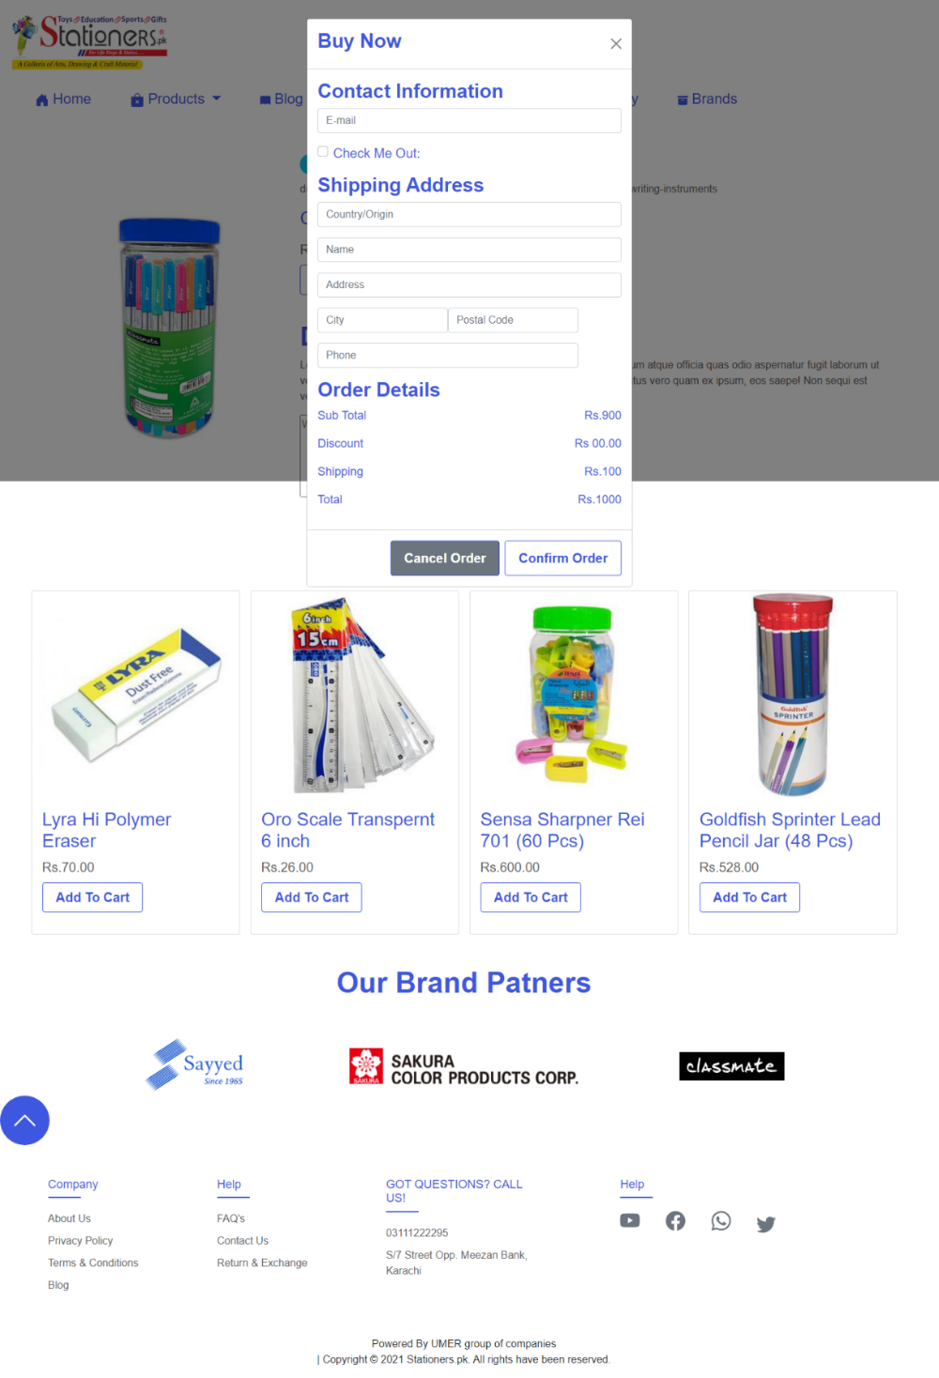

Order Confirmation Pop-up :

After The User gets user buys or makes a purchase, a confirmation message will pop up in the front giving acknowledgement of the order being received. Hence this is also a very important feature of our website. Screenshot is down below:

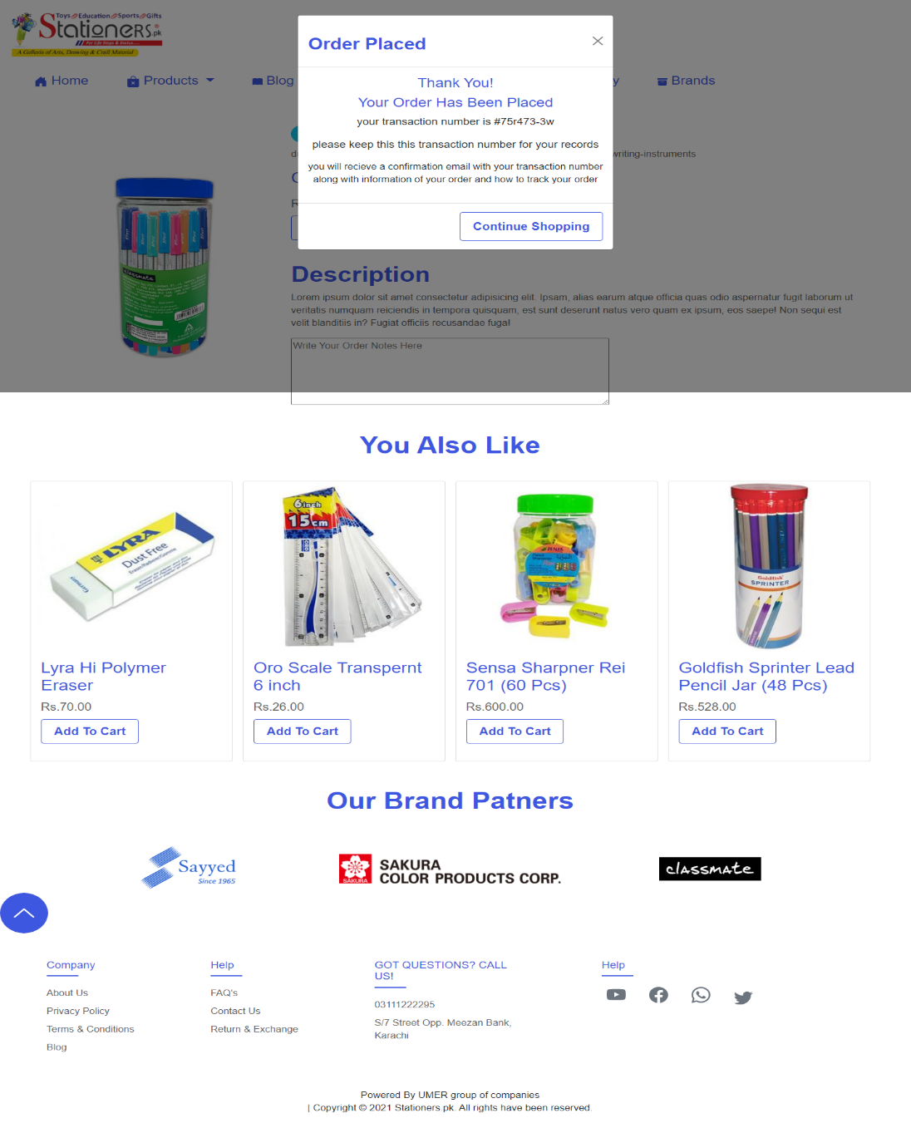

(Snapshots of Individual Pages)

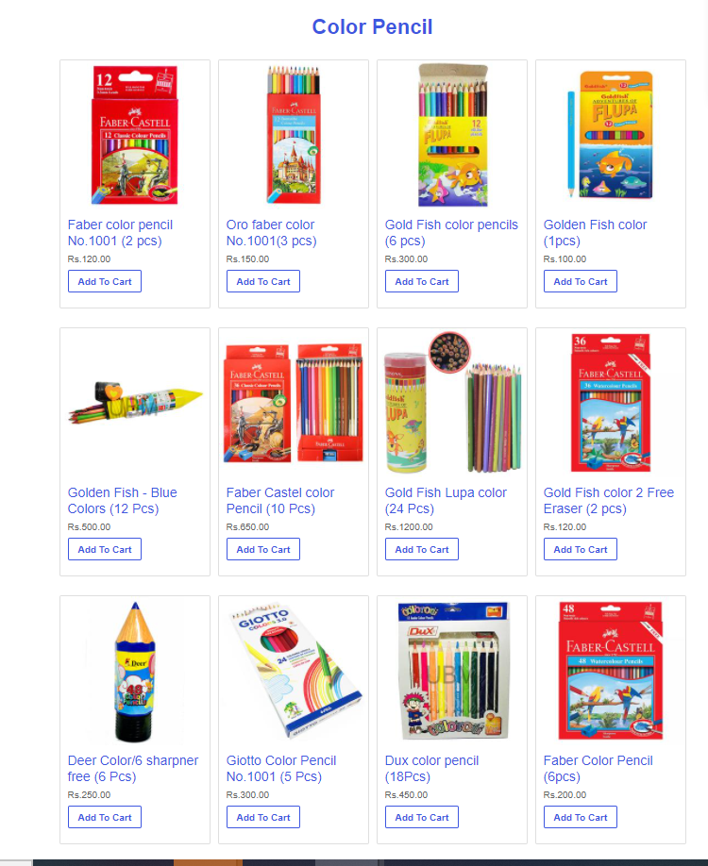 Color Pencils:

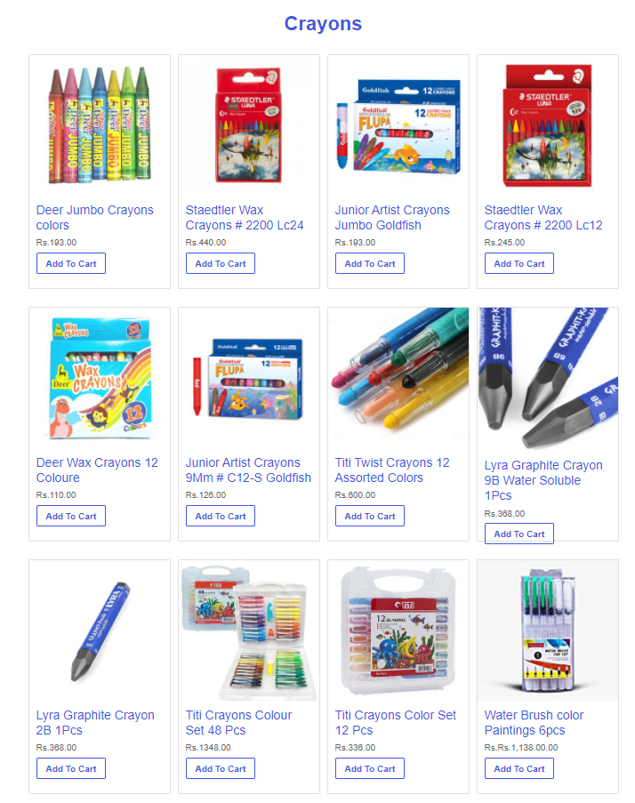Crayons :

Erasers:

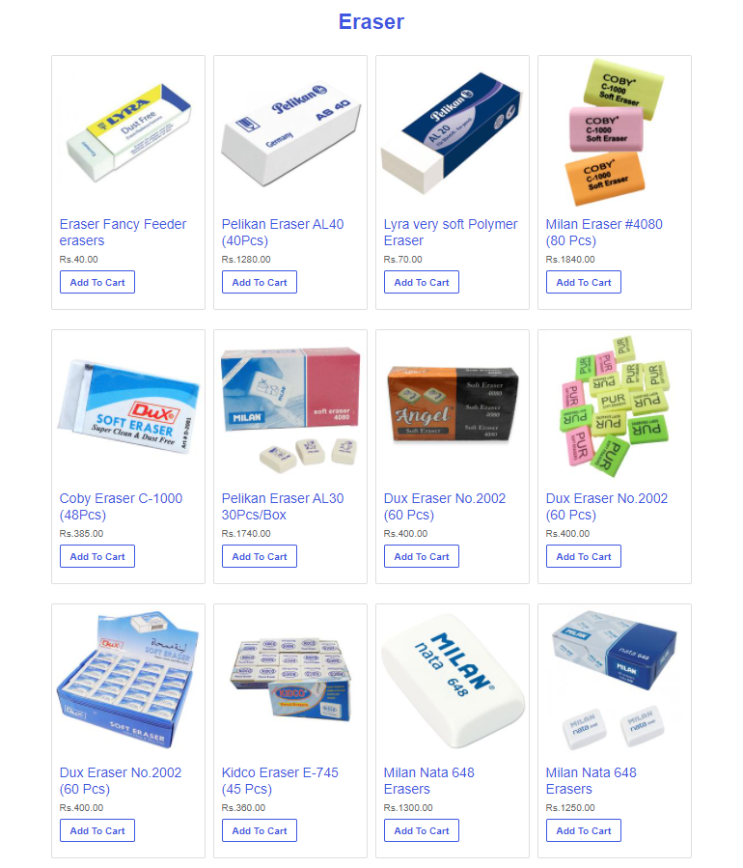

Gums :

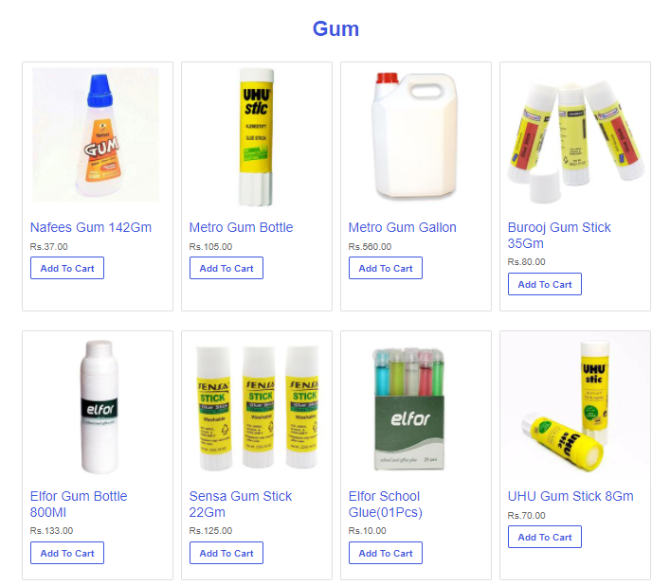

hIGH LIGHTERS :

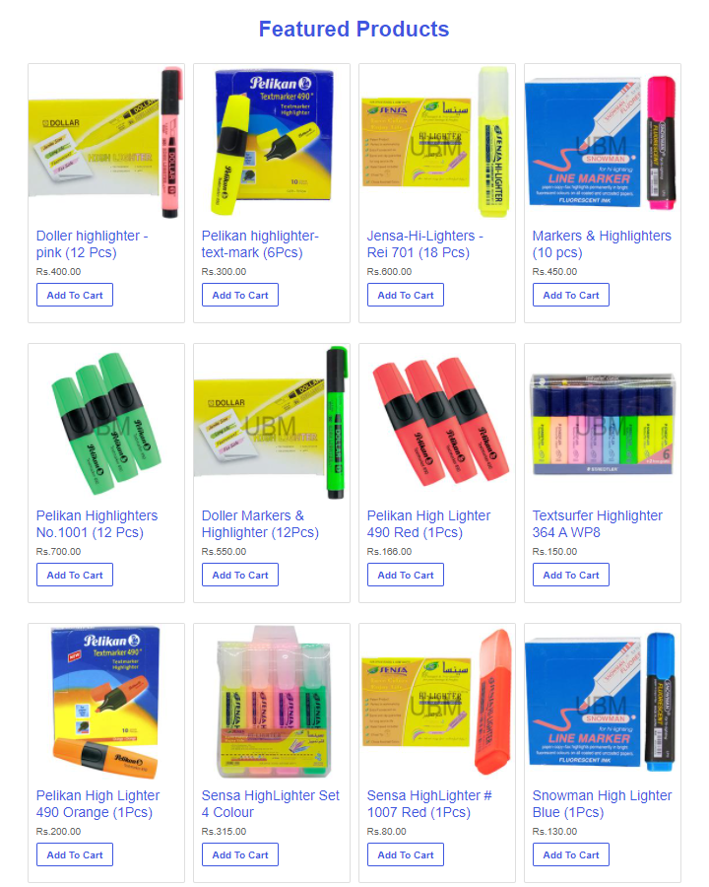

INks:

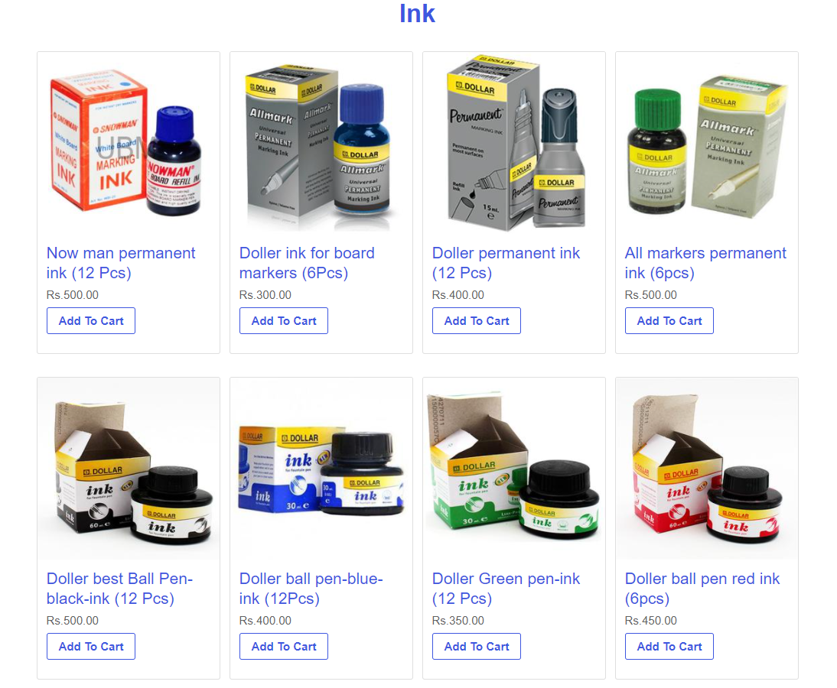

Reviews and Descriptions:

We have also Introduced a review and description page. In which user can give his feedback regarding the product and can take rating of the user according to their experience by being on this website.

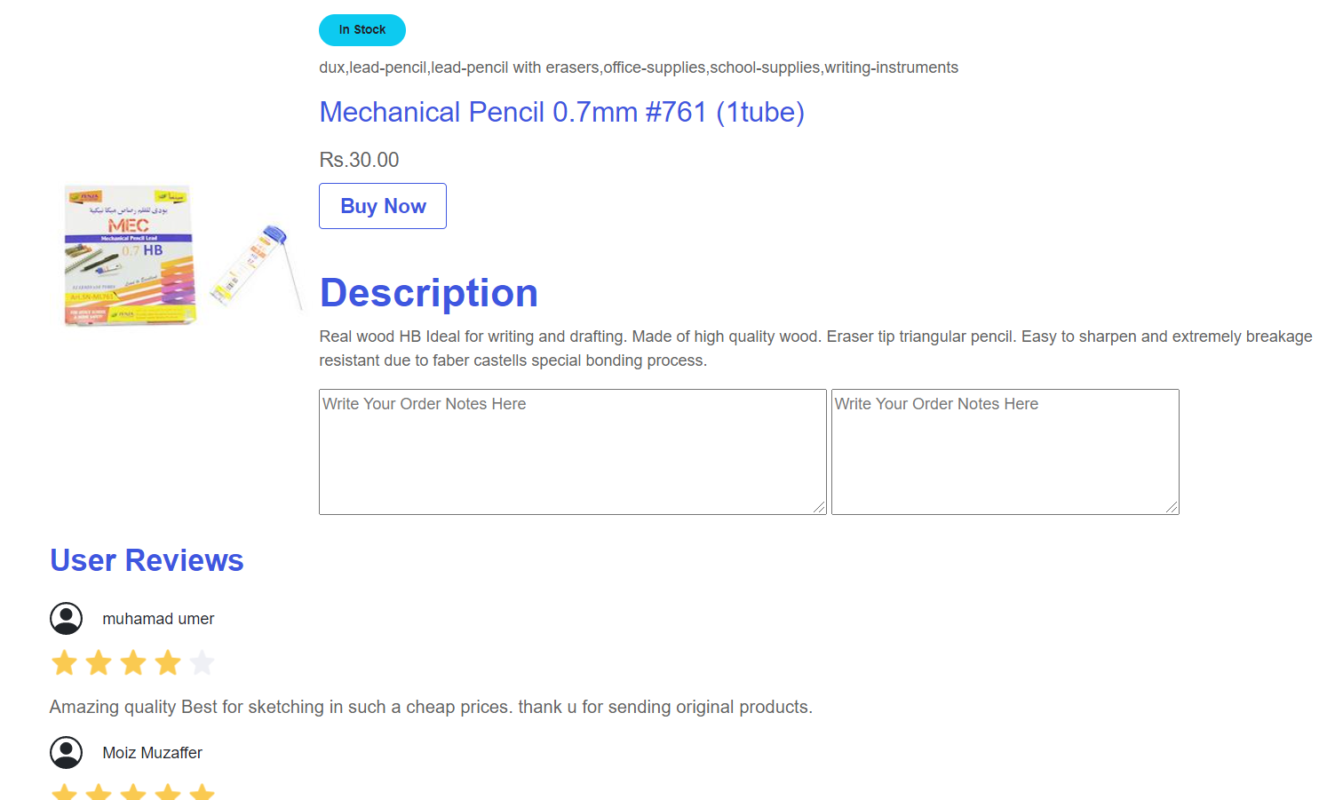

FAQ’s :

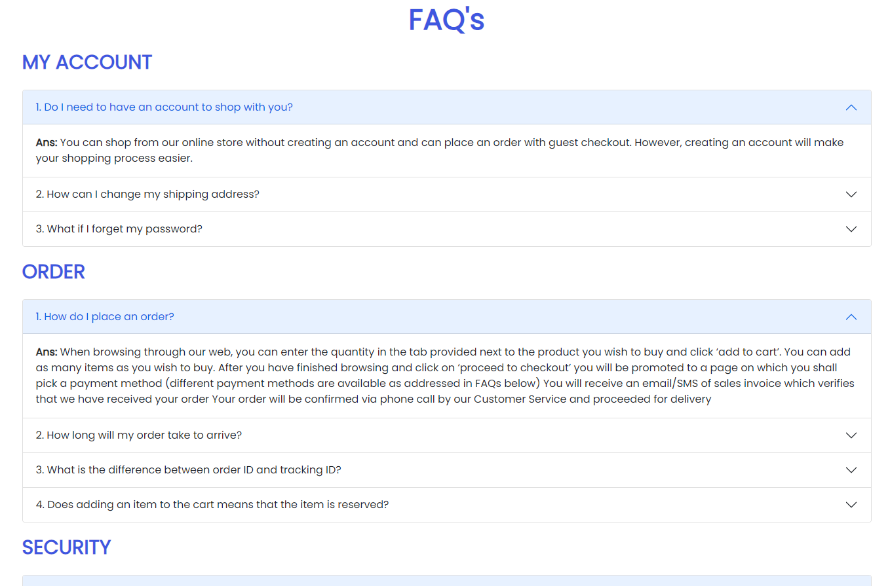

CERTIFICATE OF COMPLETION

**This is to certify that the following students of Aptech of Batch PR-2021-06-E**

Student-1: **Muhammad Umer** I.D No. 1322584

(To)

Student-2: **Muhammad Fardeen** I.D No. 1323357

(To)

Student-3: **Jan Sher Tarazai** I.D No. 1322647

(To)

Student-4: **Wajid Ahmed** I.D No. 1322580

**have successfully completed their final year project titled**

“ Stationary Website ”

__________________

Sir Taqi Rizvi

Designation

Aptech Instittute of Learning

**Table of Content**

* **Introduction Page Page 1**
* **Acknowledgement Page 2**
* **Group Members Page 3**
* **Information related to our website Page 4-8**
* **Certificate of completion Page 9**